University of Maryland
CMSC 421: Introduction to Artificial Intelligence

Project 1: Informed Search Algorithms for Travelling Salesman Problem

Part 1: Nearest Neighbor, Nearest Neighbor + 2-opt, Repeated Randomness Nearest Neighbor

Jaehyun Kwak
2025.09.22

Table of Contents
- Introduction
- Algorithm Setup
- Experiment Setup
- Results and Discussion

- Introduction
The Travelling Salesman Problem (TSP) is one of the most representative NP-hard combinatorial optimization problems. The goal of the problem is finding the shortest possible tour visiting each city once and returning to the starting point.
The goal of this project is to implement and evaluate different types of algorithms for TSP, including greedy heuristics, exact search, and stochastic metaheuristics. The algorithms are tested on 10 randomly generated adjacency matrices for each problem size ranging from 5 to 30 cities. Performance is evaluated using wall-clock time, CPU time, and tour cost.
Here in the part 1, greedy heuristics (NN, NN+2Opt, RRNN) are covered. Comparisons of the algorithms and answers for the Questions to Consider are made.

- Algorithm Setup
- Nearest Neighbor
Nearest Neighbor, the base of all the three algorithms, visits the closest unvisited node until all are visited. The pseudocode for NN is as followed:

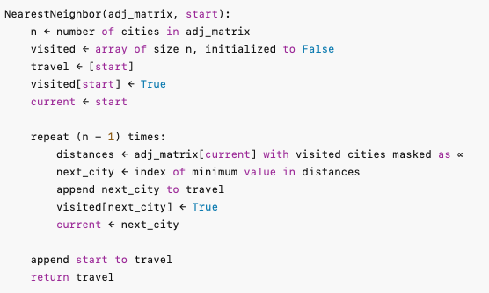
<Algorithm 1: Nearest Neighbor (NN) for TSP>

For each of the n cities, the algorithm scans all unvisited cities to find the nearest one. In the implementation, the adjacency matrix is stored as a NumPy array. At each step, the algorithm constructs a distance array using np.where to assign ∞ to already visited nodes. The next city is then chosen using np.argmin. The travel routes are stored in a list, with the start node appended at the end of to complete the cycle.

- Nearest Neighbor + 2-Opt
Nearest Neighbor + 2-Opt combines a greedy constructive heuristic with a local improvement step. First, a tour is built by repeatedly visiting the nearest unvisited city (NN). Then, the 2-Opt procedure iteratively shortens the tour by removing two edges and reconnecting the path if the swap reduces the total length, until no further improvements are made.
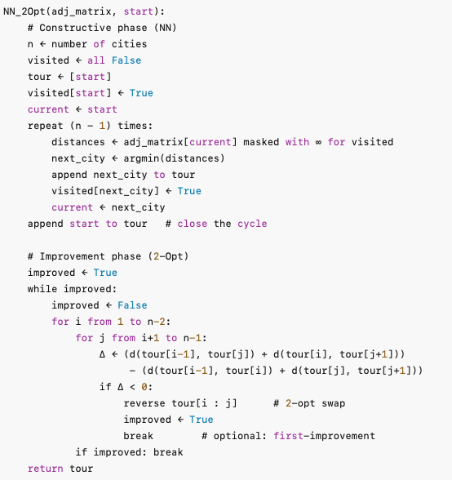
<Algorithm 2: Nearest Neighbor + 2-Opt>

- Repeated Random Nearest neighbor (RRNN)
The Repeated Random Nearest Neighbor (RRNN) algorithm is a stochastic extension of the Nearest Neighbor heuristic. Instead of deterministically selecting the nearest city at each step, the algorithm considers the $k$ closest unvisited cities and randomly chooses one as the next step. This process is repeated multiple times (num_repeats). To further improve solution quality, a 2-Opt local search is applied to each candidate tour.
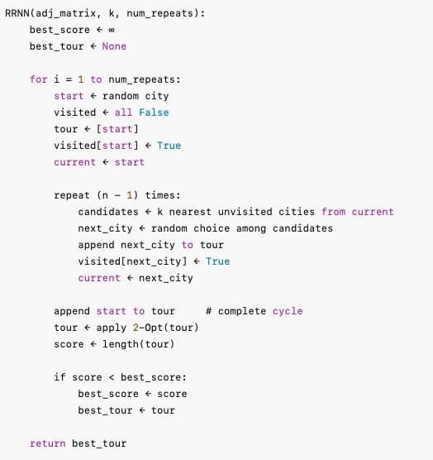
<Algorithm 3: Repeated Random Nearest Neighbor>

- Experiment Setup
To evaluate the greedy algorithms, ten given n by n adjacency matrices were used, each problem size $n ∈\{5, 10, 15, 20, 25, 30\}$. Each algorithm was executed on all instances, and performance was measured in terms of wall-clock time, CPU time, and tour cost.
For the RRNN algorithm, the hyperparameter tuning was made. Two sets of experiments were run:
- $k$ sweep: varying the candidate list size $k ∈ \{1, 2, 3, 5, 8, 10, 12, 15\}$ while fixing the number of repeats.
- Num_repeats sweep: varying the number of repetitions $numrepeats ∈\{1, 2, 5, 10, 15, 20, 30, 50, 10\}$ while fixing $k$ at its best value.

After selecting the best-performing hyperparameters, the comparison of NN, NN+2Opt, and RRNN across all problem sizes was made. For each algorithm and each instance, multiple runs were executed, and the median wall time, CPU time, and cost were calculated. These medians were plotted against the number of cities to visualize the scalability of the algorithms.
- Results and Discussion
Figure 1 gives the median tour costs of the three algorithms as the number of cities increases. It is clear that none of the three algorithms finds the true optimal tour, for their heuristic nature. Among them, NN consistently produces the worst costs, reflecting its purely greedy nature. NN+2Opt improves significantly upon NN by refining the initial greedy tour with local swaps, resulting in lower costs across all problem sizes. RRNN achieves the lowest costs overall, benefiting from randomization and multiple repetitions that increase the possibility of finding better tours. To sum up, the algorithms here do not solve the TSP optimally, but they illustrate how heuristic refinements can improve practical performance. (Question 1)
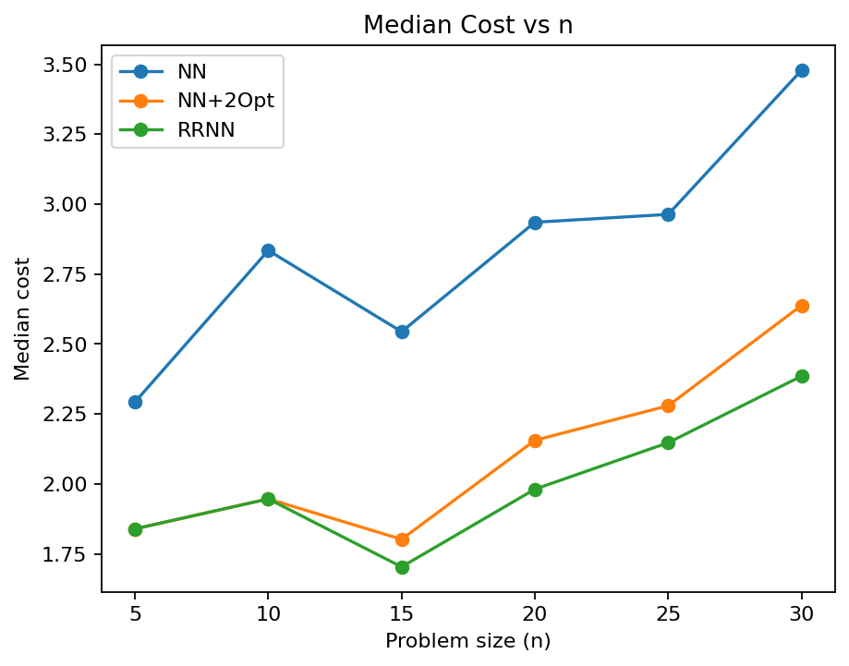
<Figure 1: Cost vs Cities>

Figures 2 and 3 present the median CPU times and wall-clock runtimes, respectively. NN is the fastest algorithm overall. NN+2Opt is only slightly slower, since 2-Opt quickly converges on small inputs. RRNN requires a lot more time, and its runtime grows in proportion to the number of cities gets bigger. This is expected, as RRNN constructs multiple randomized tours and applies 2-Opt to each, whereas the others only construct a single tour. Nevertheless, even RRNN remains efficient within the tested range ($n≤30$), below 0.02 seconds. Therefore, NN is the quickest algorithm, but this speed comes as the tradeoff for accuracy, while RRNN sacrifices some runtime in exchange for the best solution quality. (Question 4)
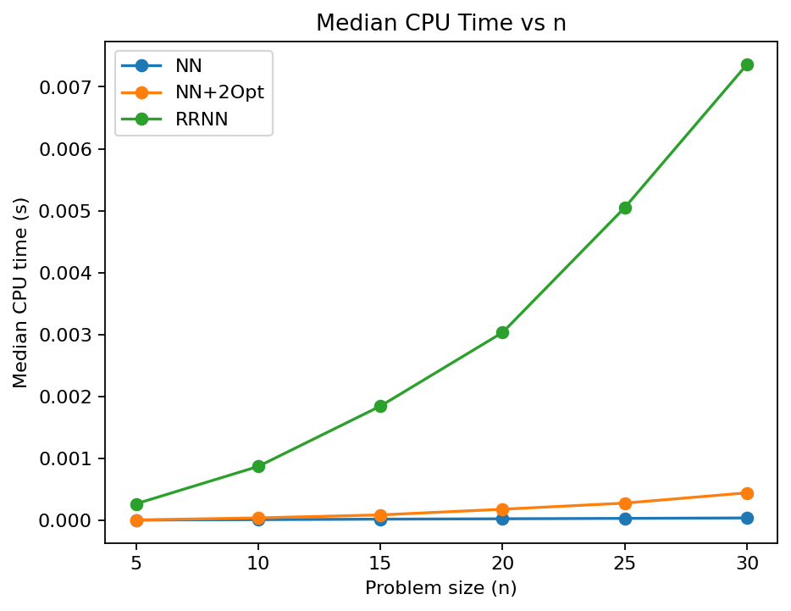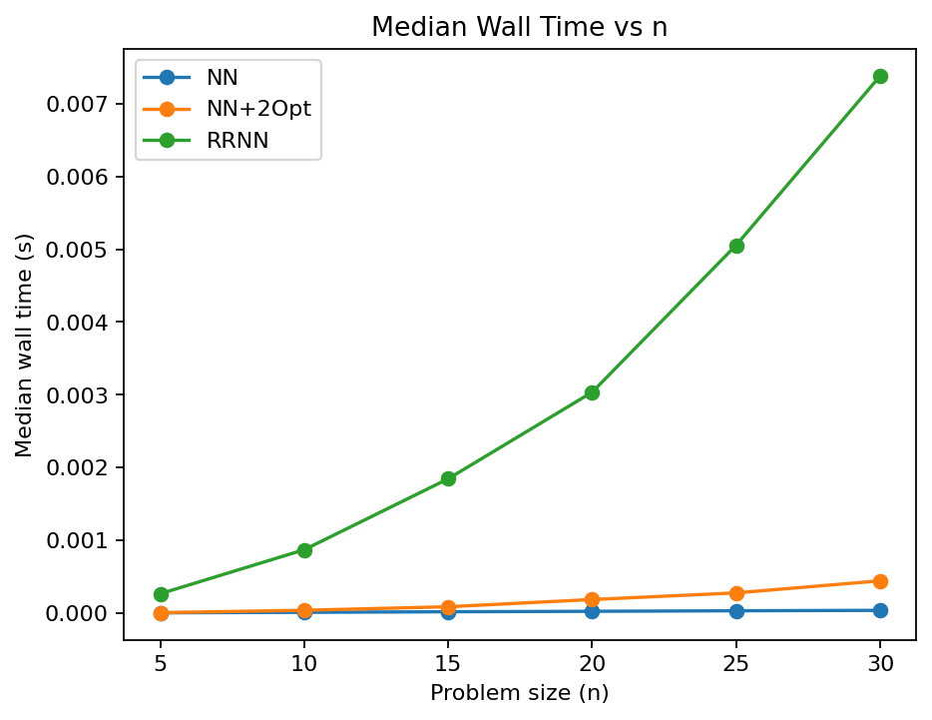
<Figure 2: CPU time vs Cities>, <Figure 3: Runtime vs Cities>

In Figure 4, the median tour cost fluctuates a lot across different values of $k$. This is due to the randomized choice over top k-closest cities, which also raise the probabilities of choosing a bad candidate. To stabilize this fluctuation, we could modify the algorithm to select the closest city as the next option, but it will also make it more vulnerable to be stuck in local optima.
Figure 5 shows the expected trade-off more clearly. With only one repetition, performance is poor. Increasing to 10-20 repetitions already produces competitive results, while only diminishing improvements are made over twenty repetitions. The trade-off is explicit: fewer repeats are faster but less reliable, more repeats improve quality but increase runtime proportionally. (Question 3)
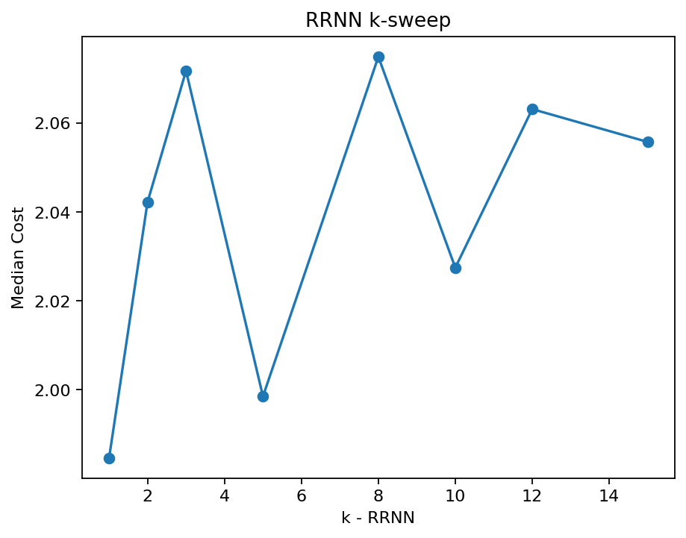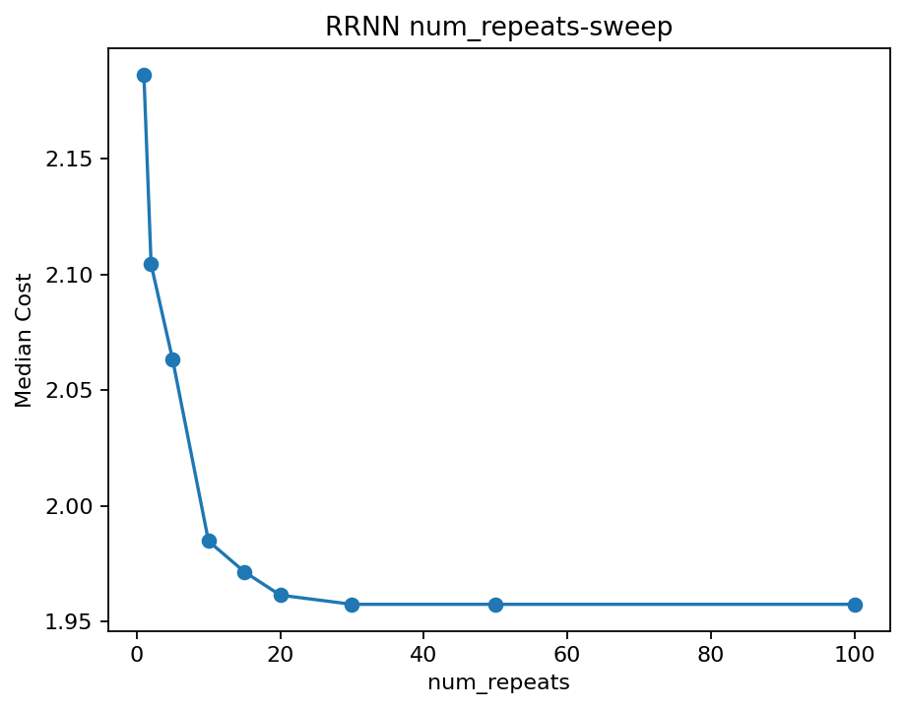
<Figure 4: $k$ vs Median Cost>, <Figure 5: num_repeats vs Median Costs>

Finally, the observed figures align with the theoretical time complexities of these algorithms. (Question 5) NN constructs the tour in $O\left(n^{2}\right)$ time, NN+2-Opt requires $O\left(n^{2}\right)$ for construction plus up to $O\left(n^{3}\right)$for iterative 2-Opt refinement, and RRNN has complexity $O\left(rkn+rn^{2}-rn^{3}\right)$, where r is the number of repeats and $k$ is the candidate set size. Because we only tested problem sizes up to $n = 30$, these complexity differences do not explode in practice; this is why NN and NN+2-Opt runtimes appear negligible in Figures 2 and 3, while RRNN shows a modest but noticeable increase as $n$ grows.

